# **6. ETHERNET LAN SWITCHING: PART 2**

### **Ethernet Frame Structure**

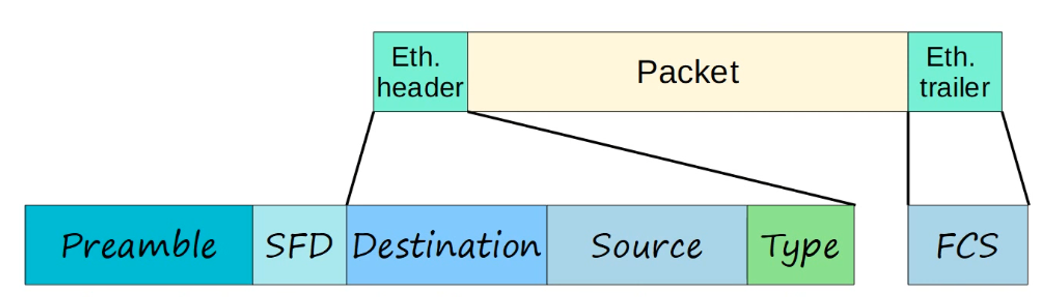

**Components:**

* **Ethernet Header**: 5 fields
  + Preamble (7 bytes)
  + SFD (1 byte)
  + Destination Address (6 bytes)
  + Source Address (6 bytes)
  + Type/Length (2 bytes)
* **Ethernet Trailer**:
  + Frame Check Sequence (FCS - 4 bytes).

**Keynote**:

* The **Preamble + SFD** is not usually considered part of the Ethernet Header.
* **Header + Trailer = 18 bytes (6 + 6 + 2 + 4)**.

### **Minimum Ethernet Frame Size**

* **Total Minimum Size**: 64 bytes (Header + Payload + Trailer).
* **Minimum Payload (Packet)**:
  + 64 bytes - 18 bytes (Header + Trailer) = 46 bytes.
  + If the payload is less than 46 bytes, **padding bytes** (0's) are added.

### **Address Resolution Protocol (ARP)**

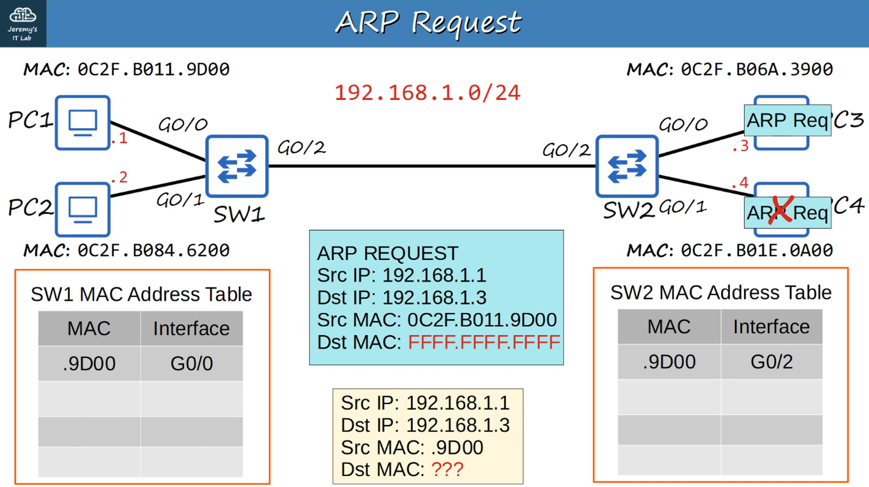

* **ARP (Address Resolution Protocol)**: Used to map a known Layer 3 address (IP) to a Layer 2 address (MAC).
* Consists of:
  + **ARP Request** (Broadcast): Sent to all hosts on the network.
    - Fields: Source IP, Destination IP, Source MAC, Broadcast MAC (FFFF.FFFF.FFFF).
  + **ARP Reply** (Unicast): Sent to the requesting host.
    - Fields: Source IP, Destination IP, Source MAC, Destination MAC.

### **PING**

* **Purpose**: Tests network reachability and measures round-trip time.
* **Messages Used**:
  + ICMP Echo Request.
  + ICMP Echo Reply.
* **Type**: Unicast.

**Command Syntax**:

PC1# ping <ip-address>

* By default, Cisco IOS sends **5 ICMP requests/replies** (100 bytes each).
* **Ping Results**:
  + . = Failed ping.
  + ! = Successful ping.

### **Useful Cisco IOS Commands**

#### **Show ARP Table**

PC1# show arp

(show arp -a for windows, macOS, linux)

* Displays the ARP table of a host.

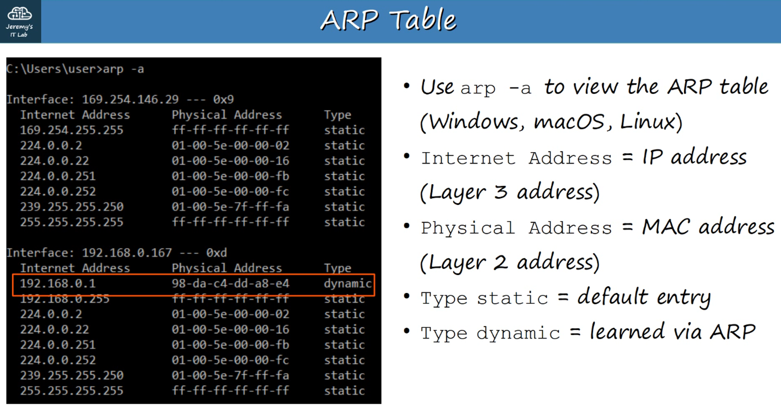

#### **Show MAC Address Table**

plaintext

Copy code

SW1# show mac address-table

* Displays the switch's MAC address table:
  + **VLAN**: Virtual LAN.
  + **MAC Address**: Learned MAC addresses.
  + **Type**: Dynamic/Static.
  + **Ports/Interfaces**: Associated switch ports.

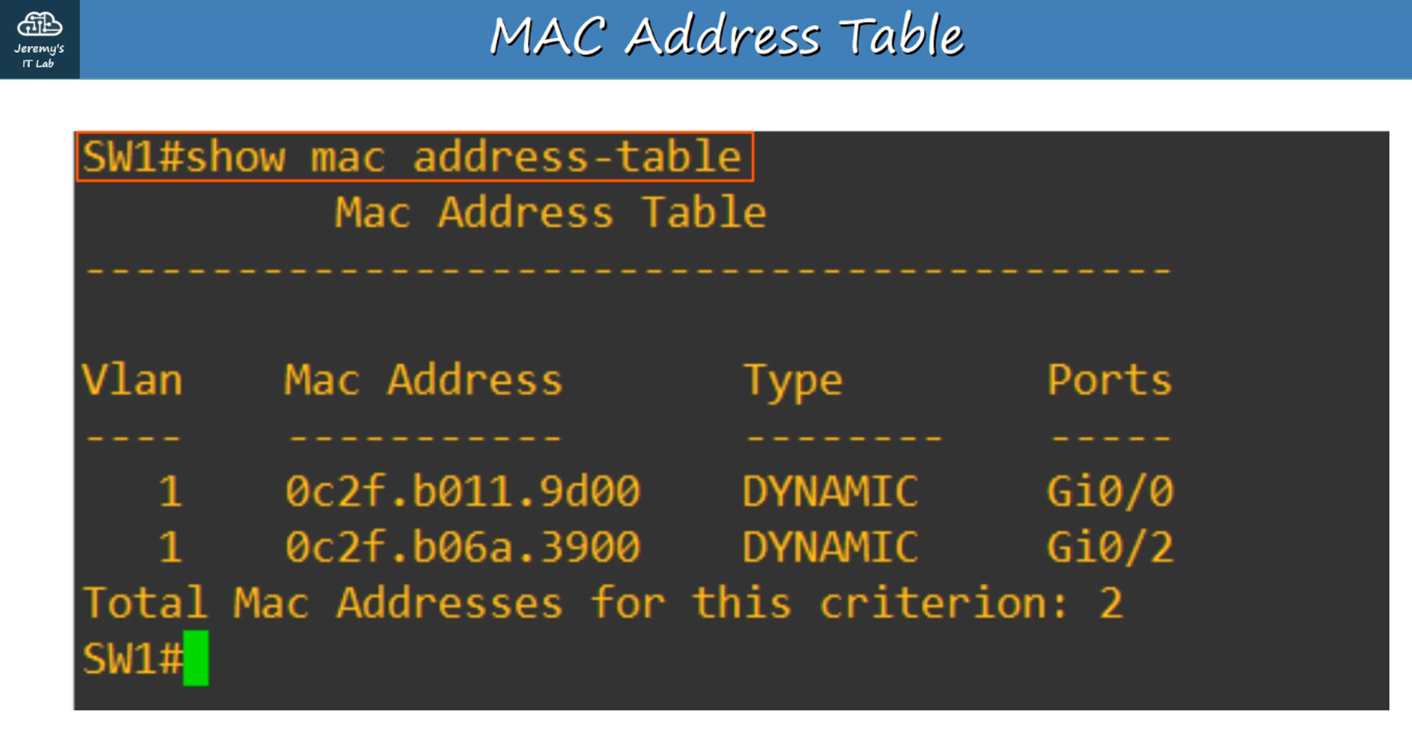

#### **Clear MAC Address Table**

1. **Clear Entire Table**:

SW1# clear mac address-table dynamic

1. **Clear Specific MAC Address**:

SW1# clear mac address-table dynamic <MAC address>

1. **Clear by Interface**:

SW1# clear mac address-table dynamic interface <Interface>

